Moose Habitat Surveyor
http://mhs.jimweller.net/

Jim Weller
CS 470 – Project Write-up

May 2, 2006
Table of Contents

Abstract 1
1. Introduction 1
2. Project Overview 1
3. Project Requirements 1
3.1 Functional Requirements 1
3.2 System Specifications 2
4. System Design 3
4.1 User Interface Design 3
4.2 System Architecture 4
5. Software Development Process 4
5.1 Testing and Debugging 5
5.2 Work Breakdown 5
6. Results 6
7. Summary and Conclusions 6
8. References 7
Appendix A: Installation Media 8
Appendix B: User Manual 8
Appendix C: Code Listing 8
Appendix D: Developers Blog 8

Abstract
Measuring the density of certain plant species in an area and their current year’s growth is important for a number of biological applications, including determining availability of forage for herbivores. Traditionally, methodologies involved working sites in grids much like archeology digs or using expensive aerial and spectral equipment. These methodologies, while exact or broad, are time and/or cost prohibitive. Dr. Don Spalinger’s proposed methodology will use a random sampling model and statistical projections. This project implements the measurement, recording and visualization component of the new methodology.

Introduction
This software project was developed for the Biology Department at the University of Alaska Anchorage. It is intended for use with agencies like the US Forest Service as well as for biology students doing field work in upper division courses. Biologists work to measure the biomass of certain regions for different applications like resource management or herbivore sustainability. I worked directly with Dr. Don Spalinger on a weekly basis to fit the application to an evolving set of requirements.

Project Overview
The purpose of this system is to facilitate the collection of biomass data from outdoor study areas. The application allows a group of field biologists to use a portable PC (generally a tablet PC) which is integrated with data sampling hardware to take measurements and counts of plants in a predefined space. The goal of the system is to retrieve systematic data samples from pre-chosen GPS waypoints and export the data into a format that lends to analysis and incorporation into GIS systems.

Project Requirements
Dr. Spalinger and I have worked to edify the requirements of the project. The requirements started with a well defined process, but not well quantified (e.g. How many meters? How many samples?). The project has been well quantified now thanks to constraints from hardware and time, but new research is altering the process, and hence scenarios, and hence functional requirements. Since Dr. Spalinger’s sampling model was (and is) still evolving I chose the prototyping lifecycle.

Functional Requirements
The functional requirements of the system are listed here in descending priority. That is the most important requirements are listed first. Items in Red are not completed in the end of semester milestone.

- Field Biologists must be able to import GIS/GPS latitude and longitude coordinates into the application as waypoints of sites to visit and survey.
- Field Biologists, having arrived at a waypoint, must be able record one or more plant species and plant patches of those species’ spatial relationships to each other within a 25 meter radius.
- Field Biologists, in measuring a particular instance of a plant species, must be able to sample 9 CurrentYearsGrowth, map their spatial relationships, measure the spatial location of the CurrentYearsGrowth base and tip, and record the diameter of the CurrentYearsGrowth base.
- Field Biologists must be able to categorize spatial areas in terms of three depth levels, 0-1m, 1-2m, and 2-3m.
- Field Biologists, after field sampling, must be able to export the resultant biomass data set into an orthogonal format for analysis.
- Field Biologists should have data automatically time stamped.
- Field Biologists should be able record the names of Field Biologists that work on a particular field trip
- Field Biologists should be able to save and load the state of the application and sampling into a file. Daylight, weather, battery and a host of other conditions can place time restrictions on Field Biologists. So, the application must be able to stop and resume in the middle of a process.
- Hardware feedback and adjustment. The application could keep the user notified that hardware is online and functioning. It should also provide instructions and/or interfaces to manage hardware.
- Field Biologists could be able to undo and/or redo and/or adjust existing data.

System Specifications

Software Requirements
- Microsoft Windows XP SP2 or higher
- Microsoft .NET Runtime 1.1 or higher*
- Polhemus PATRIOT™ Drivers*
- Microsoft Managed DirectX 9.0c*

* These items are bundled on the installation media

Hardware Requirements
- Polhemus Patriot
You will need a Polhemus PATRIOT ™ dual sensor motion tracker (3D radio pen) in order to measure three dimensional coordinates.
- Mitutoyo Calipers (optional)
USB attached Mitutoyo calipers can make measuring small distances much simpler because the measurement and text input are combined into a single action. If you don’t have Mitutoyo Calipers then measurements must be entered as text manually.
- Microsoft Windows XP SP2 compatible computer
The hardware requirements for MHS are the same as the requirements for Windows XP. Additionally, you will need a USB slot for the Polhemus and optionally for the Mitutoyo Calipers.
- Tablet PC (optional)
A touch screen computer running Microsoft XP Tablet Edition can make input much easier because mouse and keyboard are not required, text strings can be input as handwriting and a tablet is easier to hold in the field.

System Design
Since C# and C++ are the programming languages used to implement the project an object oriented approach was used. The MVC architecture is employed to isolate Dr. Spalinger’s model from the interface.

User Interface Design
MHS uses a single window graphical user interface to control and view model data. The main screen is shown below for a thorough decomposition of the interface see the user manual referenced in Appendix B.

`
Figure 3-1 MHS User Interface

- Menu Bar contains menus to manipulate the model and view
- Polhemus Readout gives real time feedback about the position of the Polhemus Patriot and the target random reference point
- Model Hierarchy is a tree view of the entire FieldTrip hierarchy from FieldTrip to Waypoint to PlantPatch to CurrentYearGrowth
- Model Details shows an aerial view of the selected Waypoint on the first tab
- Model Details shows the properties of the selected Waypoint, PlantPatch or CYG on the second tab
- Polhemus Status Bar at the bottom of the screen shows the status of the Polhemus USB connection
- PlantPatch 3D View shows a 3D model of the currently selected PlantPatch and sometimes instructions to guide sampling

System Architecture
The MVC architecture was used as the guiding architecture. This allowed me to separate the model from the control and display modules. The high level view of the architecture can be seen in the following diagram. The original design document had specified that the Polhemus would be implemented as a Windows service, but my successful research into OLE alleviated that need. So the Polhemus was integrated directly into the application rather than as a stand alone application.

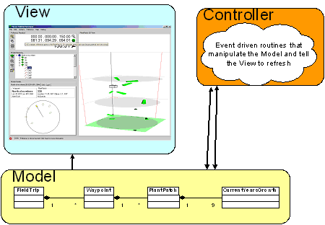

This overall design was decomposed into 4 Visual Studio Projects
- CPolhemus is a C++ OLE component that exposes the Polhemus to C#. Its is part of the Controller sub-architecture.
- MhsModelCSharp is a C# implementation of Dr. Spalinger’s model.
- MhsApplication is the Controller and View sub-architectures as a C# application and controls.
- MhsInstaller is a project to build an installable bundle.

Software Development Process
Since the projects functional requirements and scenarios were changing to reflect Dr. Spalinger’s research I chose a structured prototyping lifecycle. This was particularly effective since I was learning as I went on many of the technologies including OLE, C#, Polhemus and .NET Windows Forms. The whole project used evolutionary prototyping, but the last three weeks of the semester were reserved for 1 week prototyping cycles. Those were used to make functional changes specified by Dr. Spalinger.

Testing and Debugging
I spent a lot of time testing and debugging. This consumed probably 30% of the man hours and meetings. Plus, I had the challenge of debugging two languages, C++ and C#, across a software boundary, OLE. Plus, debugging direct3d which functions at a per-frame level in a 20 FPS system is challenging because results move quickly. Here’s a synopsis of some of the debugging techniques:

- Most debugging was done with the Visual Studio debugger
- File I/O was debugged with contrived samples and visual inspection
- C++ code used the TRACE() macro

I had 3 test sessions with Dr. Spalinger the first two were primarily to get his evaluation on the interface between human and Polhemus. He had a number of tweaks to the prototype including audio feedback, increased geometry proportions, and increased graphics frame rate. The last session he had built an indoor mockup of a PlantPatch. The indoor mockup worked good but buildings with steel in there construction and adjacent EMF signals like 802.11 can interfere with the Polhemus functionality. This third test session lead to a huge number of functional requirements changes in the ordering and number of operations that a biologist performs when sampling. Most of these functional changes were too much too late and will have to be rolled into a another prototyping cycle.

Work Breakdown
The Gantt chart shows my work schedule. I the four bars across the top represent persistent tasks like research that pervaded the entire project. You can see that a few small tasks were performed in parallel like the TreeView and DataGrid components because they were so tightly coupled. Otherwise, most of the tasks were tiered as dependent on prior tasks. The milestones at the bottom represent public presentations and major deliverable dates. This was one of my most accurately estimated and run projects thanks to training in CS401.

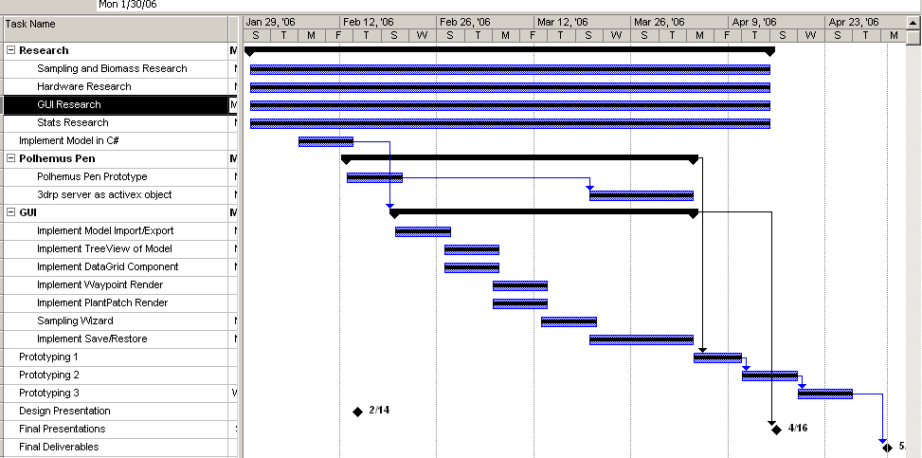

Results
Moose Habitat Surveyor was completed successfully according the original requirements. Dr. Spalinger is quite pleased with the progress and plans to pursue the line of research more. I’m excited that I’ll continue to work on MHS as a CS498 individual research project this summer.

The source, binary, manual, and a video of this CS470 Spring 2006 Milestone are available on the project website http://mhs.jimweller.net. See the Appendices for details

Summary and Conclusions
Moose Habitat Surveyor, a software application for recording biomass measurements, was completed on time and in accordance with the specifications. The prototyping lifecycle enabled me to manage a host of new-to-me technologies and changing design requirements. The MVC architecture provided a framework and guiding design principle for structuring the application. I’m glad I used Microsoft Project to manage my time. The developer’s blog helped keep ideas fresh, maintain visibility, and increase traceability

It is a real treat to work in Visual Studio with C#. C# is a nice to use and read language with a big class library. C# has some nice built-ins like XML serialization and on the fly type converters. I’m pretty proud of the C++ OLE component, but that whole mess of MFC, ATL, COM, and OLE is pretty obtuse in C++. I probably spent 10% of the man hours on that alone. C# or C++, Visual Studio makes writing and debugging code easier.

The project was (and will be) exciting because it has a real client, Dr. Spalinger, and a potential for immediate use in a number of forestry and land management agencies. The system uses cutting edge hardware and software which is enticing to the student programmer.

References
- CS401 Moose Habitat Survey Application, fall 2005, Dr. Don Spalinger, University of Alaska Anchorage
- Object Oriented Software Engineering using UML, Patterns, and Java by Bernd Bruegge and Allen Dutoit [ISBN 0-13-047110-0] http://wwwbruegge.in.tum.de/OOSE/WebHome
- Applying Robustness Analysis on the Model–View–Controller (MVC) Architecture in ASP.NET Framework, using UML http://www.codeproject.com/aspnet/ModelViewController.asp
- Polhemus makers of the PATRIOT 3DRP http://polhemus.com/PATRIOT.htm
- Rapid Development by Steve McConnell [ISBN 0-07-285060-4]
- Wikipedia GIS Page, http://en.wikipedia.org/wiki/GIS
- Wikipedia GPS Page, http://en.wikipedia.org/wiki/Gps
- Wikipedia UTM Page,
http://en.wikipedia.org/wiki/Universal_Transverse_Mercator_coordinate_system
- Mitutoyo makers of USB Calipers http://www.mitutoyo.com/
- Quantifying the forest http://www.hubbardbrook.org/yale/watersheds/w6/biomass-stop/stop-7.htm
- Estimating Biomass and Biomass Change of Tropical Forests: a Primer http://www.fao.org/docrep/W4095E/w4095e00.htm#Contents
- SOPAC/ICCEPT Pacific Islands Biomass Energy Resource Assessment Training Course http://www.iccept.ic.ac.uk/research/projects/SOPAC/PDFs/07%20Methodologies.ppt%20%5BRead-Only%5D.pdf
- Development of Software Tools for Ecological Field Studies Using ArcPad http://gis.esri.com/library/userconf/proc03/p0333.pdf
- Crop Circle™ ACS-210 Plant Canopy Reflectance Sensor http://www.hollandscientific.com/literature/Manual.pdf
- Software for Computing Plant Biomass - BIOPAK Users Guide http://www.fs.fed.us/pnw/pubs/gtr340.pdf
- Wordpress personal publishing platform http://wordpress.org/
- How to call C++ code from Managed, and vice versa (Interop) http://blogs.msdn.com/deeptanshuv/archive/2005/06/26/432870.aspx
- Converting Managed Extensions for C++ Projects from Pure Intermediate Language to Mixed Mode http://msdn.microsoft.com/library/default.asp?url=/library/en-us/vcmex/html/vcconconvertingmanagedextensionsforcprojectsfrompureintermediatelanguagetomixedmode.asp
- OtterBox Table PC Case http://www.otterbox.com/products/pc_cases/tablet/
- Panasonic ToughBook http://panasonic.com/toughbook
- Simple service base class for Windows http://www.codeproject.com/system/ServiceBase.asp
- A more complete list of web references is available on the project website. See Appendix D.

Appendix A: Installation Media
An MHS binary is downloadable from the project website packaged as an MSI.

http://mhs.jimweller.net/mhs/MhsInstaller/Release/MhsInstaller.msi

Appendix B: User Manual
The user manual for MHS is available online as a word document and is bundled in the MSI installer as an HTML document. The HTML document also services as the application’s help file.

http://mhs.jimweller.net/mhs/doc/User Manual.doc

Appendix C: Code Listing
The source code for MHS is available in its entirety online as a zip file. All code is managed in a single Visual Studio .NET 2003 Solution file, mhs.sln

http://mhs.jimweller.net/mhs.zip

Appendix D: Developers Blog
Progress, obstacles, and design choices are recorded on a developer’s blog available at

http://mhs.jimweller.net

