Moose Habitat Surveyer (MHS)
Requirements Analysis Document
University of Alaska Anchorage
CS401 Software Engineering
Fall, 2005
Group Name: “Cold Moose Chasers”
Max Konovalov, Software Engineer
Chris Kulhanek, Software Engineer
Dr. Don Spalinger, Project Owner
Jim Weller, Lead Software Engineer

Table of Contents
1 Introduction 1
1.1 Purpose of System 1
1.2 Scope of System 1
1.3 Objectives and Success criteria 1
1.4 Definitions, acronyms, and abbreviations 1
1.5 References 2
1.6 Overview 2
2 Current system 3
3 Proposed system 3
3.1 Overview 3
3.2 Functional requirements 3
3.3 Nonfunctional requirements 4
3.3.1 Usability 4
3.3.2 Reliability 4
3.3.3 Performance 4
3.3.4 Supportability 4
3.3.5 Implementation 4
3.3.6 Interface 5
3.3.7 Packaging 5
3.4 System models 5
3.4.1 Scenarios 5
1. Scenario: Import Waypoints From Agency 5
2. Scenario: Sample Biomass 5
3. Scenario: Measure CYG 9
4. Scenario: Export Waypoint’s Data To Agency 9
3.4.2 Use case model 9
3.4.2.1 ImportWaypoints 9
3.4.2.2 FieldTrip 10
3.4.2.3 EnumerateSpecies 11
3.4.2.4 MeasurePlantPatch 12
3.4.2.5 SamplePlantPatchCYGs 12
3.4.2.6 MeasureCYG 13
3.4.2.7 Export Waypoint’s Biomass Data 13
3.4.3 Object Model 13
3.4.3.1 Data Dictionary 13
3.4.3.2 Class Diagrams 14
3.4.4 Dynamic Models 15
3.4.5 User interface paths and screen mock-ups 15

Table of Figures
Figure 3-1 Waypoint Layout Scenario Diagram 7
Figure 3-2 Measure Plant Patch Diameter Scenario Diagram 7
Figure 3-3 3DRP Pole Placement in Plant Patch Scenario Diagram 8
Figure 3-4 CYGs at depth levels relative to random 3d points scenario diagram 8
Figure 3-5 MeasureCYG Scenario Diagram 9
Figure 3-6 ImportWaypoint Use Case Diagram 10
Figure 3-7 FieldTrip Use Case Diagram 11
Figure 3-8 ExportWaypointBiomassDataUse Case Diagram 13
Figure 3-9 MHS Class Diagram 14
Figure 3-10 FieldTrip State Diagram 15
Figure 3-11 MeasureCYG Activity Diagram 15
Figure 3-12 Import Waypoint Sequence Diagram 16
Figure 3-13 Sample Patch Sequence Diagram 16
Figure 3-14 Measure CYG Sequence Diagram 17
Figure 3-15 Export Biomass Data Sequence Diagram 17
Figure 3-16 MHS Application Mockup 1 18
Figure 3-17 MHS Application Mockup 2 19
Figure 3-18 MHS Application Mockup 3 20
Figure 3-19 MHS Application Mockup 4 21

Introduction

Purpose of System
The purpose of this system is to facilitate the collection of biomass data from outdoor study areas. The system will allow external agencies to define areas to be studied, field biologists to engage in systematic sample recording, and data export for analysts to analyze the resultant data sets. The system will combine existing hardware and computing platforms into a single biomass sampling suite.

The application will allow a group of field biologists to use a portable PC (generally a tablet PC) which is integrated with tactile data sampling hardware to make measurements and counts of plants in a predefined space. The goal of the system is to retrieve systematic data samples from pre-chosen Lat/Lon waypoints and export it into a format that lends to analysis.

Scope of System
The application must allow the import of an arbitrary number of waypoints. Field biologists must be able to visit the waypoints and sample the new growth of an arbitrary number of predefined plant species. Given a species at a waypoint, field biologist must be able to sample an arbitrary number of plant patches of that species type. Field biologists sample a total of 9 CYGs in a plant patch; 3 CYGs at each of 3 depth levels (0-1m, 1-2m, 2-3m). Finally, the application must be able to export the biomass data in an orthogonal data format.

Objectives and Success criteria
- All required assignments are submitted on time and receive a course grade of B or higher.
- All documents are approved by the project development team before submission.
- All functional requirements are complete and correct.
- All scenarios are agreed satisfactory by all stakeholders.
- All functional and non-functional requirements are agreed upon by the development team.
- All deliverables are completed on or before their projected date of delivery.
- The application suite can successfully complete a trial waypoint import, field trip and biomass data export.

Definitions, acronyms, and abbreviations
- Agencies are organizations external to the system that request the measurement of biomass at waypoints. Agencies supply waypoints for field trips.
- 3-Dimensional Radio Pen (3DRP or PATRIOT) is a 3 dimensional tracking device from Polhemus which allows the mapping and recording of 3 dimensional points.
- Current Annual Growth (CAG) or Current Year’s Growth (CYG) is a biological term used to describe new growth on plants for the current year. CYGs are good moose forage.
- Calipers are a device for measuring small linear distances between two points. Calipers are used to measure the diameter of a CYG’s base. They have a USB interface to the computer system.
- Depth Level (depth) refers to the height in a plant patch at which a CYG exists. It is broken into 0-1 meter, 1-2 meters, and 2-3 meters. Low forage could be covered by snow in the winter. High forage is available to the tall moose.
- Field Trip is an excursion to a study site to measure CYGs in the area. Field trips are composed of a series of waypoints.
- Field Biologist is a user of the system that participates in field trips to waypoints, sampling biomass data.
- Geographic Information System (GIS). From http://wikipedia.org
“[…] GIS is a system for creating and managing spatial data and associated attributes. In the strictest sense, it is a computer system capable of integrating, storing, editing, analyzing, and displaying geographically-referenced information. In a more generic sense, GIS is a "smart map" tool that allows users to create interactive queries (user created searches), analyze the spatial information, and edit data.”
- Global Positioning System (GPS). From http://wikipedia.org
“[…] GPS […] is a satellite navigation system used for determining one's precise location and providing a highly accurate time reference almost anywhere on Earth or in Earth orbit.”
- Laser Range Finder is a tool for measuring large linear distances. It is used to measure a plant patch’s distance from a waypoint and to interpolate a plant patch diameter.
- Plant Patch (Patch) is a single instance of a particular plant species. From the perspective of the system, a patch is a location where CYGs will be measured at three different depth levels.
- Waypoint refers to a specific coordinate location exported from GIS and navigable by GPS. A waypoint is the center of a circle with a 15 meter radius in which plant patches will be sampled.

References
- CS401 Moose Habitat Survey Application, fall 2005, Dr. Don Spalinger, University of Alaska Anchorage
- Object Oriented Software Engineering using UML, Patterns, and Java by Bernd Bruegge and Allen Dutoit [ISBN 0-13-047110-0] http://wwwbruegge.in.tum.de/OOSE/WebHome
- Polhemus makers of the PATRIOT 3DRP http://polhemus.com/PATRIOT.htm
- Rapid Development by Steve McConnell [ISBN 0-07-285060-4]
- Wikipedia GIS Page, http://en.wikipedia.org/wiki/GIS
- Wikipedia GPS Page, http://en.wikipedia.org/wiki/Gps
- Mitutoyo makers of USB Calipers http://www.mitutoyo.com/

Overview
Measuring density of certain plant species and their current year’s growth is important for a number of biological applications, including determining availability of moose forage. There is currently no equivalent system. Older methodologies involve working in site grids much like archeology. These older methodologies try to map an entire site and make complete models of plants. The proposed methodology will use computers, a random sparse sampling model, and statistical projections. This system intends to implement the measurement and recording component of the new methodology.

Current system
There is no current system. Agencies have said they would use the application right now if it existed. The agencies interested in using this approach include the US Forest Service, US Fish and Wildlife Service, and the Alaska Department of Fish and Game.

Proposed system

Overview
From Dr. Spalinger’s “CS401 Moose Habitat Survey Application Document”:

This computer application will allow the user to digitally collect information on vegetation composition and biomass for inventorying moose habitat in Alaska. The agencies interested in using this approach include the US Forest Service, US Fish and Wildlife Service, and the Alaska Department of Fish and Game.

Field biologists will receive a set of waypoints from an agency’s GIS database. This could include any number of agencies. From the perspective of the application the waypoints are randomly chosen. The waypoints will be imported into the application from a file as sites to be surveyed.

The biologists will use GPS navigation to go to the site. They will then use a combination of integrated hardware tools potentially including a Bluetooth GPS, 3D radio pen, USB calipers and laser range finder to measure the location and dimensions of CYGs of a finite list of plant species.

After all waypoints have been visited and sampled (or the field trip ends due to other constraints) the data is exported to some orthogonal format (CSV, excel, RDBMS etc.) for processing by biometricians, agencies, and researchers.

Functional requirements
- Field Biologists must be able to import GIS/GPS latitude and longitude coordinates into the application as waypoints of sites to visit and survey.
- Field Biologists should be able record the names of Field Biologists that work on a particular area or site survey.
- Field Biologists, having arrived at a waypoint, must be able record one or more plant species and plant patches of those species’ spatial relationships to each other within a 15 meter radius.
- Field Biologists, in measuring a particular instance of a plant species, must be able to sample 9 CYG, map their spatial relationships, measure the spatial location of the CYG base and tip, and record the diameter of the CYG base.
- Field Biologists must be able to categorize spatial areas in terms of three depth levels, 0-1m, 1-2m, and 2-3m.
- Field Biologists, after field sampling, must be able to export the resultant biomass data set into an orthogonal format for analysis.
- Field Biologists should be able to resume a waypoint list of sampling. Daylight, weather, battery and a host of other conditions can place time restrictions on Field Biologists. So, the application must be able to stop and resume in the middle of a process.
- Field Biologists should be able to undo and/or redo and/or adjust existing data.
- Field Biologists must be able to save and load the state of the application and sampling into a file.
- Field Biologists should have data automatically time stamped.

Nonfunctional requirements

Usability
- Minimal Text Entry. Field sampling may occur in inclement conditions like snow or rain and Field Biologists might be wearing protective or weather gear. Where ever possible, integrated hardware should be used for data entry.
- Outdoor Equipment. A hardened computer with an outdoor screen with be needed to reasonably use the application in an outdoor environment.

Reliability
- No Network. It can be assumed that field researchers will not have network access while sampling.
- Accuracy. The time, human resources and hardware costs associated with inventorying and analyzing a study area is immense. So, complete and accurate data is a priority.

Performance
- Power Usage. It can be assumed that field researchers will not have access to AC power sources and that conservation of battery will be a priority.

Supportability
- Electronic Users Manual. Given that Field Biologists have no access to the network a user’s manual must be included on the portable pc.
- Print Users Manual. Given that Field Biologists need to conserve power on the hardware, a print user manual must be available.

Implementation
- Extensibility. Given the short duration of the CS401 course relative to the needs of the project, the application needs to be documented and designed such that future courses and projects can extend the suite.
- Programming languages. Most of the hardware devices’ APIs are implemented in C++. We will minimally have to implement objects in C++ and attempt to constrain the entire project to the C++ language.

Interface
- GUI. The interface should take advantage of modern GUI’s and the tablet PC pen interface. The interface should be intuitive and usable with minimal inputs.
- Minimal decision branching. The process of recording sample data should be sequentially driven without excessive decision branching required.
- Hardware feedback and adjustment. The application needs to keep the user notified that hardware is online and functioning. It should also provide instructions and/or interfaces to manage hardware.
- Single Application. The suite should run as a single application. The skills, time, and free hands to manipulate and navigate the operating system should be minimized (e.g. application switch or cutting and pasting). The application could be deployed to run on startup, making the tablet pc a dedicated sampling tool.

Packaging
- Windows Tablet PC operating system. The application will be designed with the Windows XP Tablet PC edition in mind. Though it should work on any 32bit windows including Windows 2000, XP, and 2003. The project does not strive for compatibility with 16 or 64 bit versions of Windows or with Windows 95, 98, and ME.
- Executable Installer. The application shall have an MSI (or equivalent) installer that contains the software and manual.
- Patches and Updates. Modifications to the software will be distributed if available.

System models

Scenarios
- Scenario: Import Waypoints From Agency
  - Actors: Agency, Field Biologist
  - Flow of events:
    - Field Biologist receives waypoint list at a text file from Agency
    - Field Biologist imports waypoints into application GUI through the file → import drop down menu.
- Scenario: Sample Biomass
  - Actors: Field Biologist
  - Flow of events: (see Figure 3-1, Figure 3-2, Figure 3-3, Figure 3-4)
    - Identify species within a 15m radius
    - Choose species that will be sampled
    - For every species that will be sampled
      - Identify patches/plants of that species
      - For every plant/patch identified
        - Biologist estimates placement of pole at nearest edge of plant/patch (pole1)
        - Measure distance from waypoint to pole1 and inputs to terminal with keyboard.
        - Biologist estimates placement of pole at farthest edge of plant/patch (pole2)
        - Measure distance from waypoint to pole2 and inputs to terminal with keyboard.
        - Place 3DRP-pole in body of plant at point randomly generated by the system on the line between the two poles
        - For each depth level (0-1m, 1-2m, 2-3m)
          - Computer selects a random point
          - Navigate the 3DRP to the point
          - Find the nearest CYG to the random point (CYG1)
          - Measure CYG1 using 3DRP to automatically input dimensions.
          - Find the nearest CYG to CYG1 (CYG2)
          - Measure CYG2 using 3DRP to automatically input dimensions.
          - Find the next nearest CYG (CYG3) to CYG1
          - Measure CYG3 using 3DRP to automatically input dimensions.
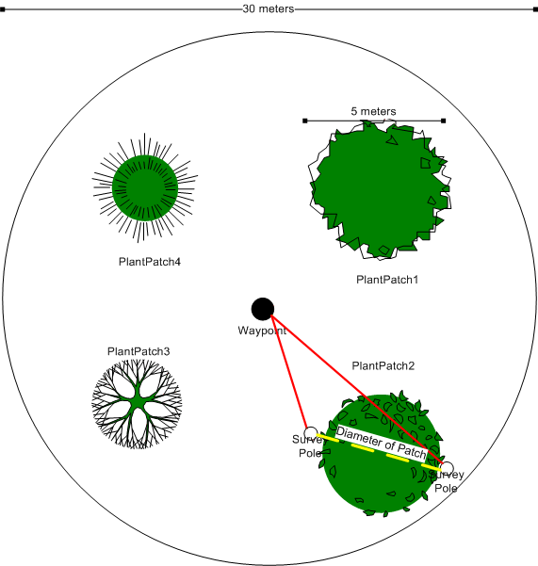
Figure 3-1 Waypoint Layout Scenario Diagram
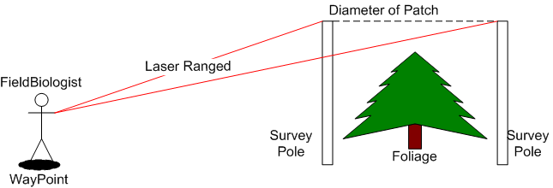
Figure 3-2 Measure Plant Patch Diameter Scenario Diagram

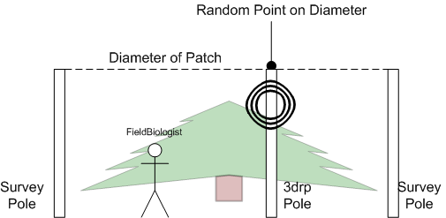
Figure 3-3 3DRP Pole Placement in Plant Patch Scenario Diagram
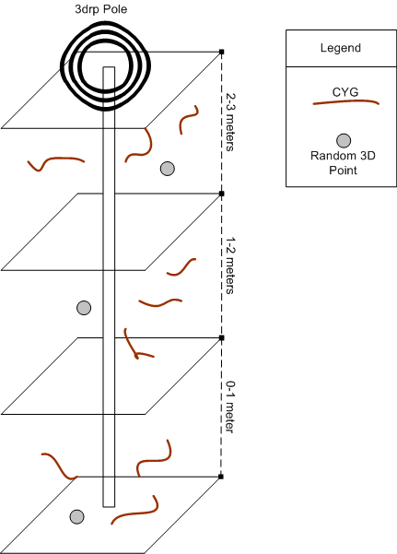
Figure 3-4 CYGs at depth levels relative to random 3d points scenario diagram

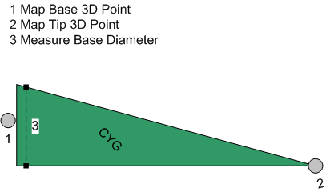
Figure 3-5 MeasureCYG Scenario Diagram
- Scenario: Export Waypoint’s Data To Agency
  - Actors: Field Biologist, Agency
  - Flow of events:
    - Field Biologist exports sample data for waypoints using the GUI drop down “export” option.
    - Field Biologist transfers data to Agency

Use case model

ImportWaypoints
Actors
- Initiated by Agency
- Communicates with FieldBiologist
Flow of Events (see Figure 3-6)
- An Agency communicates Waypoints to FieldBiologists .
- The FieldBiologists import the Waypoints into the MHS system.
Entry Conditions
- An Agency initiates a field trip with FieldBiologists.
Exit Conditions
- The Waypoints are successfully imported into the MHS system.

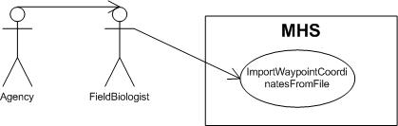
Figure 3-6 ImportWaypoint Use Case Diagram

FieldTrip
Actors
- Conducted by FieldBiologist
Flow of Events (see Figure 3-7)
- FieldBiologist navigate to Waypoint.
- FieldBiologist identify plant species at each Waypoint.
- FieldBiologist identify PlantPatches for each PlantSpecies.
- FieldBiologist measure PlantPatches (includes use case MeasurePlantPatch).
- FieldBiologist sample CYGs in a PlantPatch (includes use cases SamplePlantPatch).
- FieldBiologist navigate to next Waypoint.
Entry Conditions
- FieldBiologist begin the FieldTrip
Exit Conditions
- The PlantPatches of PlantSpecies are completely sampled at all Waypoints in a FieldTrip.
- OR
- The FieldTrip is terminated for external reasons like time, resources, or injury.

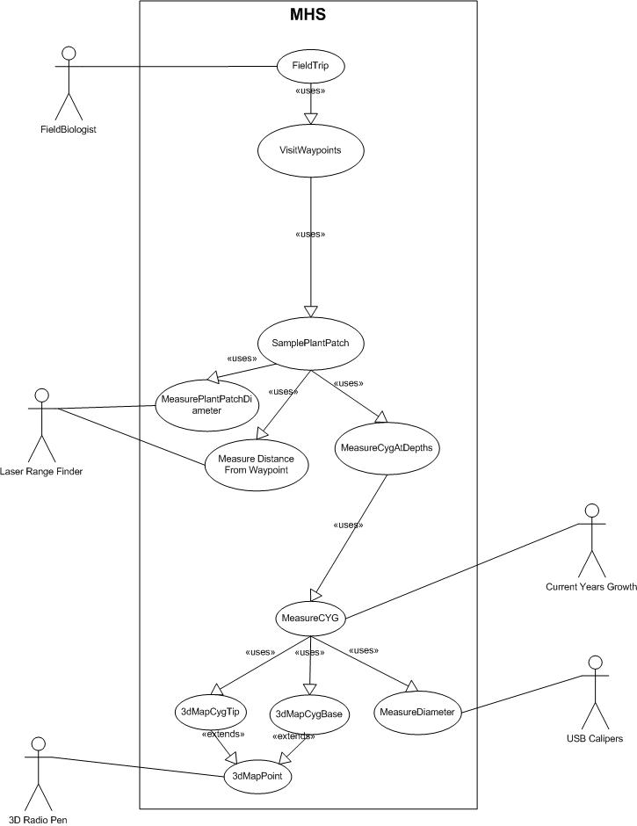
Figure 3-7 FieldTrip Use Case Diagram

MeasurePlantPatch
Actors
- Conducted by FieldBiologist
Flow of Events (see Figure 3-7)
- FieldBiologists select PlantPatch of PlantSpecies at a Waypoint.
- FieldBiologists measure distance to point in PlantPatch nearest to Waypoint using LaserRangeFinder.
- FieldBiologists measure distance to point in PlantPatch farthest from Waypoint using LaserRangeFinder.
- System calculates random point on the line between the nearest and farthest points in the PlantPatch.
- FieldBiologists sample PlantPatch’s CYGs from the random point (includes use case SamplePlantPatchCYGs).
Entry Conditions
- Waypoint contains PlantPatch of PlantSpecies.
Exit Conditions
- PlantPatch’s distances and diameter are measured.
- All CYGs at the PlantPatch are sampled.

SamplePlantPatchCYGs
Actors
- Conducted by FieldBiologist
Flow of Events (see Figure 3-7)
- System generates random 3D point for each of three 1 meter depth levels
- FieldBiologist orients 3DRP to 3D point in each depth level
- FieldBiologist samples CYG nearest to 3D point, data is input with 3DRP. (includes use case MeasureCYG).
- FieldBiologist samples CYG nearest to first CYG , data is input with 3DRP (includes use case MeasureCYG).
- FieldBiologist samples CYG next nearest to first CYG , data is input with 3DRP (includes use case MeasureCYG).
Entry Conditions
- 3DRP oriented at random point in PlantPatch
Exit Conditions
- 3 CYGs are measured at each of 3 depth levels (total of 9 CYGs).

MeasureCYG
Actors
- Conducted by FieldBiologist
Flow of Events (see Figure 3-7)
- FieldBiologist measures 3D location of CYG’s base using 3DRP
- FieldBiologist measures 3D location of CYG’s tip using 3DRP.
- FieldBiologist measures diameter using Calipers.
Entry Conditions
- CYG identified relative to previous CYG or random 3D point at depth level
Exit Conditions
- CYG’s base, tip, and base diameter are measured

Export Waypoint’s Biomass Data
Actors
- Initiated by FieldBiologist
- Communicates with Agency
Flow of Events (see Figure 3-8)
- The FieldBiologists export the Waypoints from the MHS system to a file.
- FieldBiologists communicate Waypoints’ biomass data to an Agency.
Entry Condition
- A FieldTrip is completed
Exit Condition
- The Waypoints are successfully exported from the MHS system.
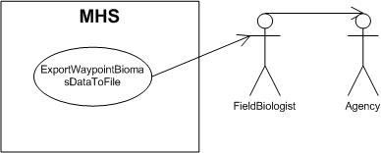
Figure 3-8 ExportWaypointBiomassDataUse Case Diagram

Object Model

Data Dictionary
The data dictionary is not represented in textual form here since classes, their methods, and their attributes are delineated in 3.4.3.2 Class Diagrams.

Class Diagrams
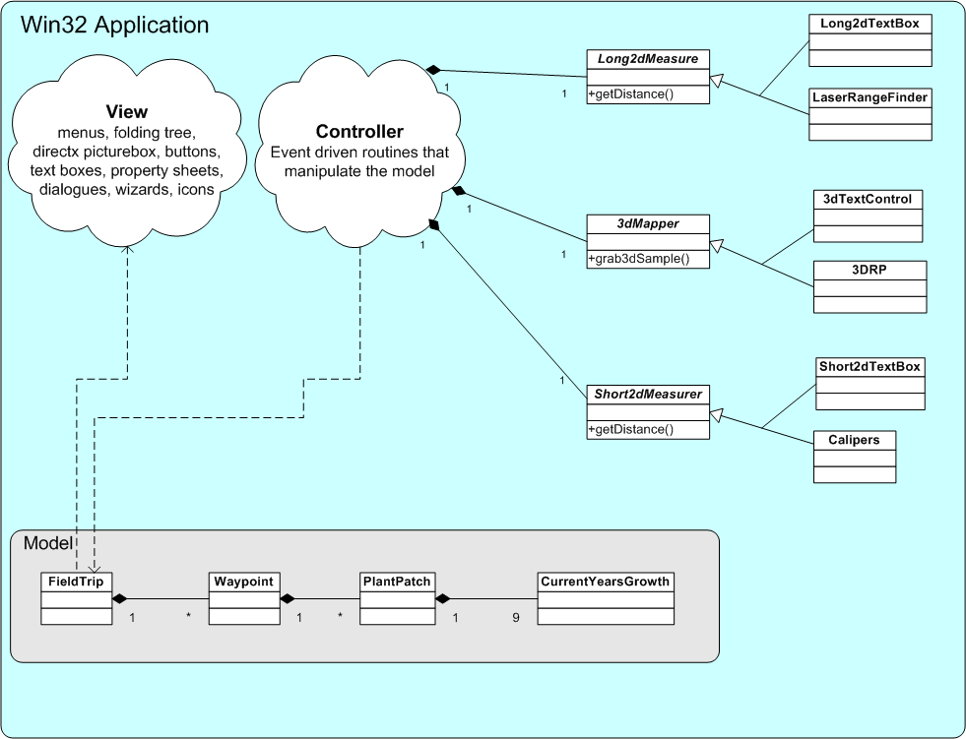
Figure 3-9 MHS Class Diagram

Dynamic Models

User interface paths and screen mock-ups
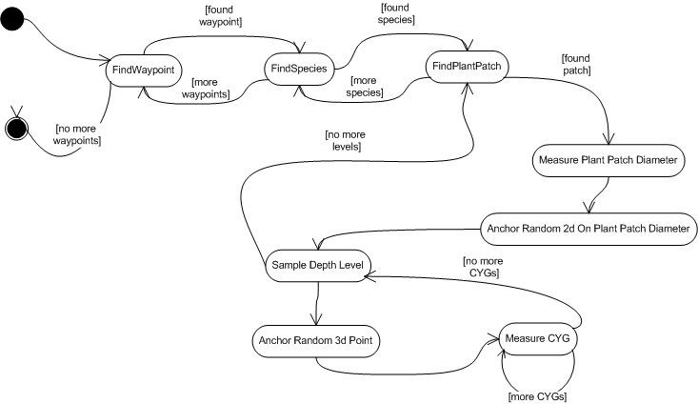
Figure 3-10 FieldTrip State Diagram
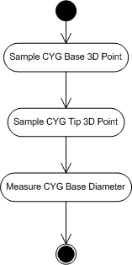
Figure 3-11 MeasureCYG Activity Diagram

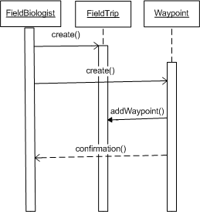

Figure 3-12 Import Waypoint Sequence Diagram

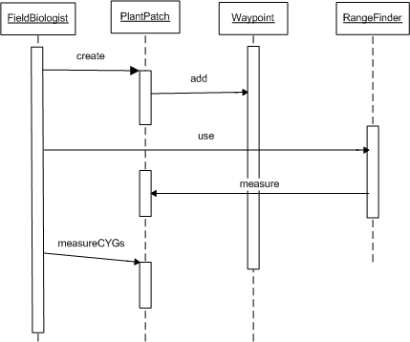

Figure 3-13 Sample Patch Sequence Diagram

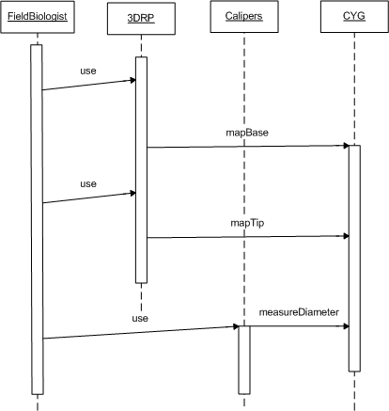

Figure 3-14 Measure CYG Sequence Diagram
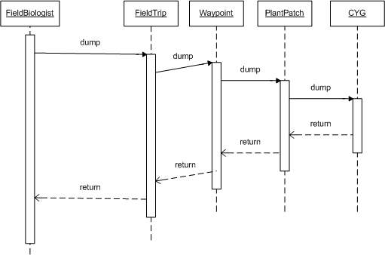
Figure 3-15 Export Biomass Data Sequence Diagram

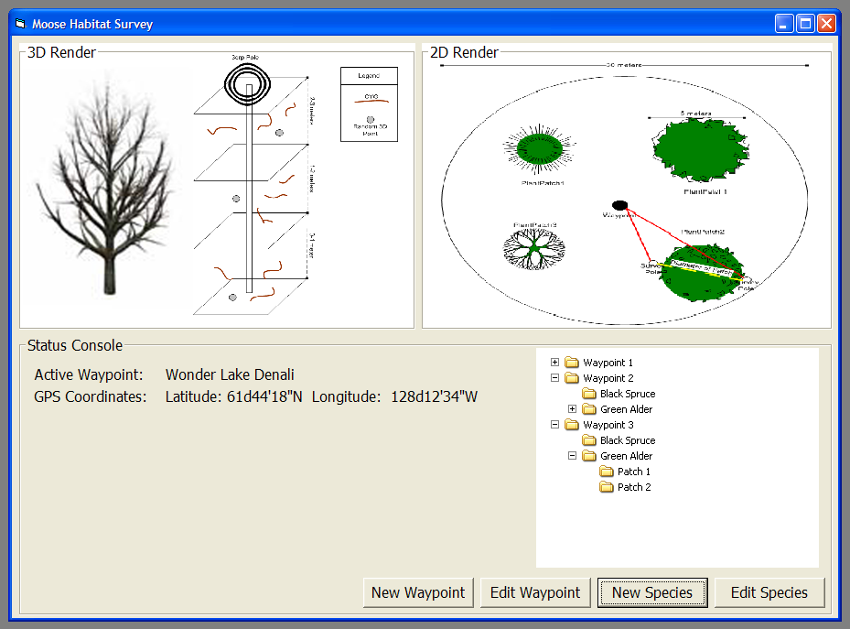
Figure 3-16 MHS Application Mockup 1
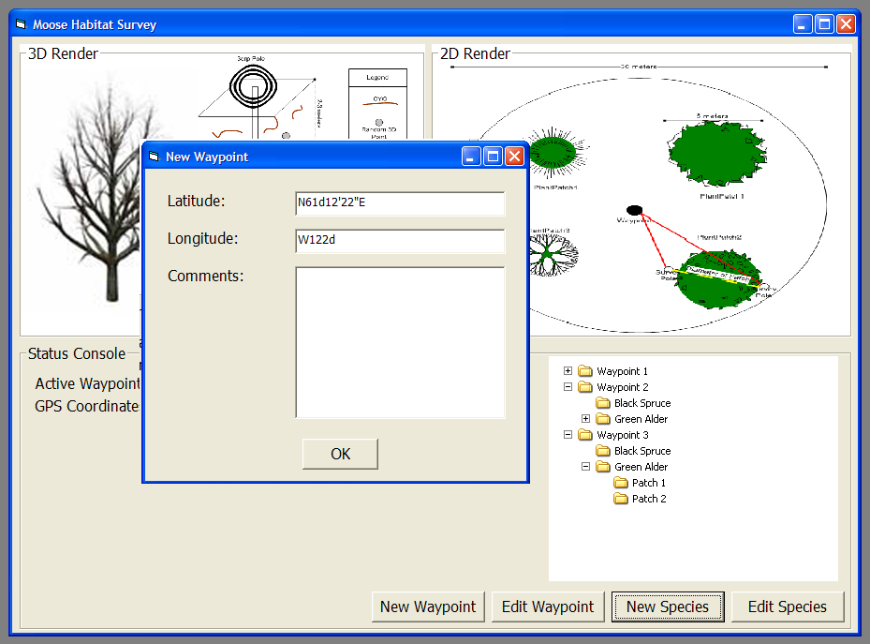
Figure 3-17 MHS Application Mockup 2
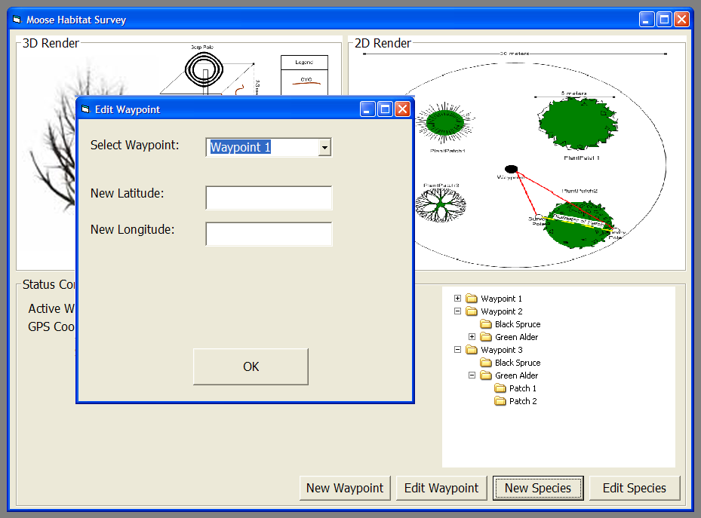
Figure 3-18 MHS Application Mockup 3
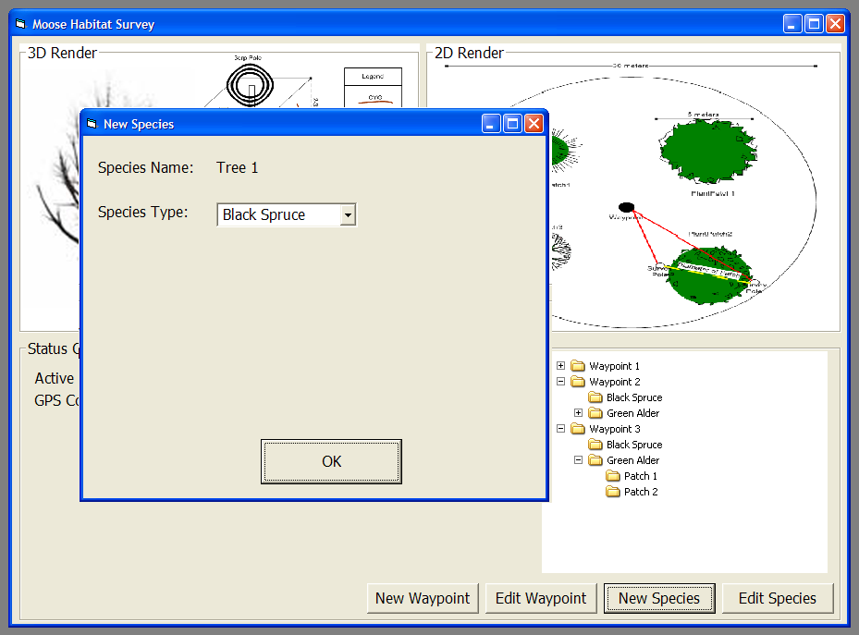
Figure 3-19 MHS Application Mockup 4

